1. GIT CONFIGURATION
- To check if Git client is installed properly: Open Git bash shell and execute
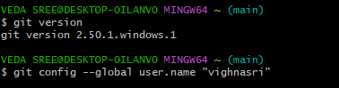
- user level configuration of user ID and email ID execute

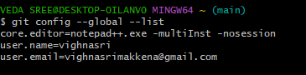
- check if the configuration is properly set

- Install notepad++ if not installed and set the path in environment variables
- After setting environment variables close your previous git bash and open it again
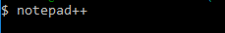
- Type in git bash notepad++

- create an alias command for notepad++.exe
- configure the editor
- verify if notepad++ is the default editor
- Open Git bash shell and create a new project “GitDemo”
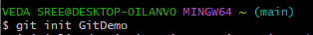

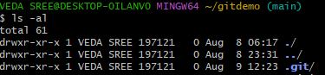
- Git bash initializes the “GitDemo” repository

- create a file “welcome.txt”

- to see text in welcome.txt
cat welcome.txt
- check status
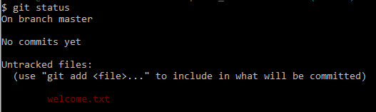
git status

- make the file to be tracked by Git repository

- add multi line comments, we are opening default editor to comment. Execute the command

- To check if local and “Working Directory” git repository are same, execute git status

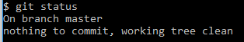

- Sign up with gitlab and create remote repository “GitDemo”
- To pull remote repository
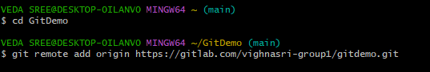

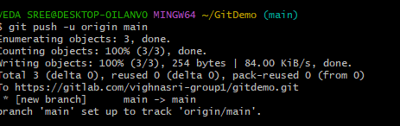
- To push the local to remote repository

